**NAME- JANHVI SINGH**

**Day_3_Assignment**

**CODE:**

**Updated HTML:**

<!DOCTYPE html>

<html lang="en">

<head>

<meta charset="UTF-8">

<meta name="viewport" content="width=device-width, initial-scale=1.0">

<title>Feedback Form</title>

<link rel="stylesheet" href="style.css">

</head>

<body class="background">

<div id="feedback-form">

<h1>Feedback Form</h1>

<p>Please provide your feedback below:</p>

<form>

<label for="name">Name:</label>

<input type="text" id="name" name="name" required>

<label for="email">Email:</label>

<input type="email" id="email" name="email" required>

<label for="feedback">Your Feedback:</label>

<textarea id="feedback" name="feedback" rows="4" required></textarea>

<label>Rate our service:</label>

<input type="radio" id="excellent" name="rating" value="excellent">

<label for="excellent">Excellent</label>

<input type="radio" id="good" name="rating" value="good">

<label for="good">Good</label>

<input type="radio" id="average" name="rating" value="average">

<label for="average">Average</label>

<input type="radio" id="poor" name="rating" value="poor">

<label for="poor">Poor</label>

<label for="service">Service Type:</label>

<select id="service" name="service">

<option value="support">Customer Support</option>

<option value="product">Product Quality</option>

<option value="delivery">Delivery Service</option>

</select>

<button type="submit">Submit</button>

</form>

</div>

</body>

</html>

**CSS:**

body.background {

font-family: Arial, Helvetica, sans-serif;

background-color: #e6e6e6;

margin: 0;

padding: 0;

display: flex;

justify-content: center;

align-items: center;

height: 100vh;

}

#feedback-form {

background: white;

padding: 20px;

border-radius: 5px;

box-shadow: 0 0 10px rgba(0, 0, 0, 0.1);

width: 400px;

border: 2px solid #ccc;

box-sizing: border-box;

}

h1, h2 {

font-size: 24px;

font-weight: bold;

color: #333;

}

p {

font-size: 16px;

color: #666;

line-height: 1.6;

}

label {

display: block;

margin: 10px 0 5px;

font-weight: bold;

}

input, textarea, select {

width: 100%;

padding: 10px;

margin-bottom: 10px;

border: 1px solid #ccc;

border-radius: 4px;

box-sizing: border-box;

font-size: 14px;

}

input[type="radio"], select {

display: inline-block;

width: auto;

margin-right: 10px;

}

button {

width: 100%;

padding: 12px;

background: #007bff;

color: white;

border: none;

border-radius: 4px;

cursor: pointer;

font-size: 16px;

margin-top: 10px;

}

button:hover {

background: #0056b3;

}

@media (max-width: 600px) {

#feedback-form {

width: 90%;

padding: 15px;

}

}

**OUTPUT:**

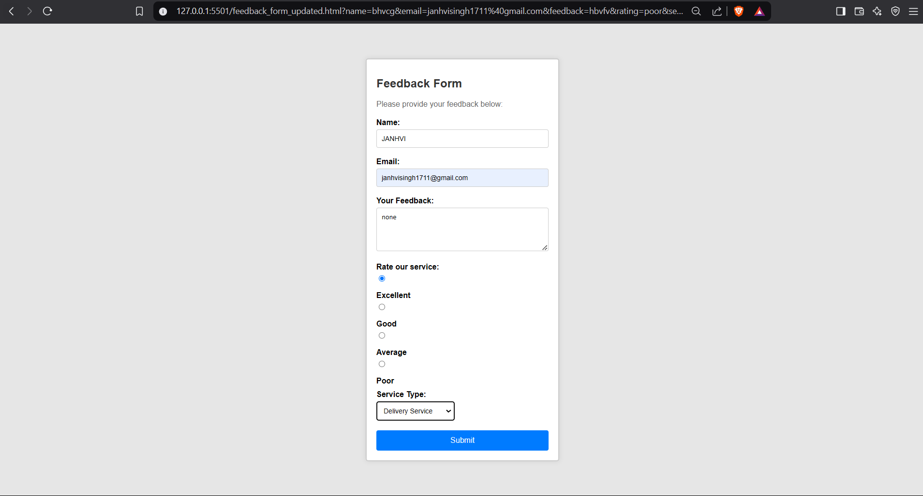

**README File:**

Files Included

feedback_form.html – Form structure

styles.css – Styling

Styling Highlights

Typography: Modern, web-safe font

Layout: Padding, margins, and flexbox for alignment

Responsive Design: Media queries for mobile support

How to Run

Open feedback_form.html in a browser and ensure styles.css is linked correctly.